Final Review

Multiple Choice
Identify the letter of the choice that best completes the statement or answers the question.

____ 1. What is the difference between a scarcity and a shortage?
a. | A scarcity occurs when producers will not or cannot offer goods or services at the current prices, and a shortage occurs when there are limited quantities to meet unlimited wants.
b. | Scarcity is the effort that people devote to a task that meets unlimited wants, and a shortage occurs when supplies of goods or services run low.
c. | A scarcity occurs when supplies of goods and services are suddenly attainable, and a shortage occurs when producers will not or cannot offer goods or services at the current prices.
d. | A scarcity occurs when there are limited quantities to meet unlimited wants, and a shortage occurs when a good or service is unavailable.

____ 2. Ben’s family purchased a dishwasher so that the family members could save time for more productive activities. What kind of production factor is this?
a. | labor capital | c. | physical capital
b. | human capital | d. | efficiency capital

____ 3. According to the “guns and butter” example, if a country decides to spend more on military goods, which of the following will happen?
a. | The country will have less money to devote to consumer goods.
b. | The country will have an equal amount of money to devote to consumer goods.
c. | The country will be forced to make trade-offs in military purchasing.
d. | The country will have more resources to devote to consumer goods.

____ 4. By the end of the summer, Jason had saved enough money for college from his job as a waiter. He even had some money left over. Although he wanted both, he decided to buy a DVD player rather than a digital camera. Which of the following is the opportunity cost in this scenario?
a. | the DVD player | c. | college
b. | the digital camera | d. | the job

____ 5. A legislative committee is weighing the pros and cons of a clean-air program. If it spends $1 million on the program, the air will be cleaner by 20 percent. If it spends $2 million, the air will be cleaner by 30 percent. If it spends $3 million, the air will be cleaner by 35 percent. After comparing opportunity costs and benefits at the margin, the committee agrees to fund the program with $2 million. Why did it not choose to appropriate $3 million?
a. | At $3 million, the air is not improved as much as the committee would like.
b. | At $3 million, the costs are no longer worth the benefits.
c. | It was too much to spend without a guarantee.
d. | The air is improved by the same amount whether $2 million or $3 million is spent.

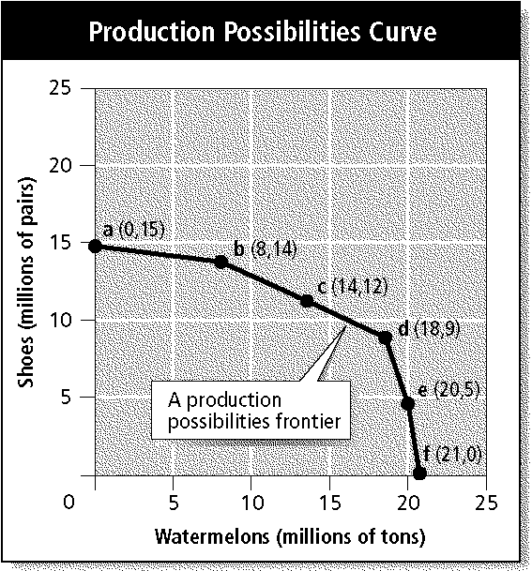

____ 6. Which of the following statements is true about the graph of a production possibilities curve?
a. | The cost of producing watermelons and shoes is roughly even on the production possibilities frontier.
b. | It costs 2 million more tons of watermelons to produce 14 million tons of shoes.
c. | The cost of moving from producing no watermelons to producing 8 million tons of watermelons is 1 million pairs of shoes.
d. | One million tons of watermelons must be sacrificed to produce 8 million pairs of shoes.

____ 7. How does a society answer the three economic questions about the production and consumption of goods and services?
a. | Its answer is based on the importance it attaches to various economic goals and societal values.
b. | Its answer is based on the importance it attaches to the stock market.
c. | Its answer is based on recent technological advances.
d. | Its answer is based solely on current environmental regulation.

____ 8. Which one of the following relies on habit, custom, or ritual to decide what to produce, how to produce it, and to whom to distribute it?
a. | a market economy | c. | a centrally planned economy
b. | a traditional economy | d. | a mixed economy

____ 9. In a free market economy, the factor market involves which type of exchange?
a. | The goods and services that households produce are purchased by firms.
b. | Firms purchase factors of production from households.
c. | Households purchase factors of production from firms.
d. | Firms loan money to households to purchase capital.

____ 10. Self-interest is the motivating force driving the free market. Which of the following is the regulating force?
a. | incentive | c. | competition
b. | group interest | d. | the invisible hand

____ 11. Centrally planned economies can work effectively toward explicitly stated goals, but which of the following is one disadvantage of such a system?
a. | Its performance almost always falls short of its ideals.
b. | These economies never produce an increase in output.
c. | The workers control all the production factors.
d. | It gives too many rewards for innovation.

____ 12. Which of the following statements is true, as market economies have evolved since Adam Smith’s time?
a. | Government intervention in the economy has decreased.
b. | Government intervention in the economy has become greater.
c. | Government intervention in the economy is based on job safety.
d. | Government intervention in the economy has stayed relatively the same.

____ 13. China, like many other nations, is undergoing a period of transition in which many of its state firms are being privatized. Which of the following statements BEST describes the change in China’s mixed economy system?
a. | The economy is moving away from a market-based system toward a centrally planned system.
b. | The private sector economy is being managed by state-appointed trustees.
c. | The free enterprise system is placing limits on property taxes and enforcing trade tariffs.
d. | The economy is moving away from central planning toward a market-based system.

____ 14. The purpose of the free enterprise system is to
a. | give consumers goods and services free of charge.
b. | eliminate economic choices.
c. | create political campaign slogans.
d. | give consumers freedom to make economic choices.

____ 15. What are some of the basic principles of free enterprise?
a. | research institutions, government restriction, and stock qualifications
b. | profit motive, legal equality, private property rights, free contract, and competition
c. | interest groups, disclosure laws, public interest, and negative regulation
d. | absolute organizations, low prices, and quality control indexes

____ 16. In which way does a public disclosure law help consumers?
a. | by allowing consumers to file grievances about products and businesses with the government
b. | by requiring companies to give consumers important information about their products
c. | by forcing companies to pay taxes based on the amount of goods and services they sell or buy
d. | by requiring businesses to report business relationships that could constitute a monopoly on the marketplace

____ 17. Which of the following is a good indicator of economic stability?
a. | foreign policy | c. | general price levels
b. | general foreign trade | d. | job-related safety

____ 18. Which word BEST completes the following sentence? Improvements in ____ allow an economy to produce more output from the same or a smaller quantity of inputs.
a. | GDP | c. | technology
b. | free enterprise | d. | communication

____ 19. Which of the following is NOT a reason for the government to provide a good or service as a public good?
a. | The good or service should be made available to everyone.
b. | Increasing the number of consumers would increase the cost to a private provider.
c. | It would be inefficient to exclude nonpayers.
d. | It would be impractical to make consumers pay individually.

____ 20. Improved technology helps create a higher standard of living for future generations by
a. | preventing drastic shifts in general price levels.
b. | reducing the number of unemployed workers.
c. | creating specialized jobs for workers.
d. | providing additional goods and services.

____ 21. When shoes at a local shoe store went on sale at 50 percent off the regular price, the store sold almost every pair of shoes it had in less than a day. By the time the stock was replenished, the sale was over and very few shoes were purchased. Which of the following does this illustrate?
a. | the income effect | c. | the law of demand
b. | the law of discounts | d. | the substitution effect

____ 22. Which of the following explains the relationship between income effect and consumption?
a. | When the price of goods goes up, people get less for their money, and consumption goes down.
b. | As incomes rise, consumption of lower-priced goods falls.
c. | When the price of goods goes up, people buy more, but consumption of the same amount of goods rises.
d. | As incomes fall, consumption of products and services stays the same, but people get less for their money.

Market Demand Schedule
Price of a  slice of pizza | Quantity  demanded per day
$.50 | 300
$1.00 | 250
$1.50 | 200
$2.00 | 150
$2.50 | 100
$3.00 | 50

____ 23. Franco’s Pizzeria sells slices of pizza for $2.00. According to the market demand schedule and assuming ceteris paribus, what happens when Franco’s raises the price to $2.50 a slice?
a. | The quantity demanded per day stays the same.
b. | The quantity demanded falls from 100 slices a day to 50 slices a day.
c. | The quantity demanded falls from 150 a day to 100 a day.
d. | The quantity demanded increases to 250 a day.

____ 24. Mariah is buying fewer boxes of macaroni and cheese, used cars, fast-food dinners, and generic products because her income rose. This shift in the demand curve caused by Mariah’s income has resulted in
a. | a decreased demand for inferior goods.
b. | a decreased demand for tangible goods.
c. | an increased demand for normal goods.
d. | a decreased demand for expendable goods.

____ 25. Which of the following is NOT a factor affecting elasticity?
a. | availability of substitutes
b. | the good’s relative importance
c. | whether the good is a necessity or a luxury
d. | the good’s price range

____ 26. According to the law of supply, the higher the price,
a. | the more consumers are willing to pay.
b. | the larger the quantity produced.
c. | the smaller the quantity produced.
d. | the more the availability of a good is reduced.

____ 27. Lily is opening a new coffee shop and is having trouble deciding on the price to charge for a cup of cappuccino. How will determining all the supply schedules of coffee shops in her market help Lily?
a. | The market supply schedule would help Lily determine the total supply of cappuccino at a certain price, based on relationships between prices and the total quantity supplied by all coffee shops in her market.
b. | The sales supply schedule would help Lily determine the minimum and maximum prices she should charge for cappuccino, based on comparisons between larger and smaller coffee shops in her market.
c. | The sales supply schedule would help Lily determine the maximum price for cappuccino in her market, based on relationships between consumers’ spending habits and current cappuccino prices.
d. | The market supply schedule would help Lily determine the lowest possible price she should ask for a cappuccino, based on the current year-end sales at the top-selling coffee shops in her area.

Marginal Product of Labor
Labor  (number of  workers) | Output  (beanbags  per hour) | Marginal  product  of labor
0 | 0 | —
1 | 4 | 4
2 | 10 | 6
3 | 17 | 7
4 | 23 | 6
5 | 28 | 5
6 | 31 | 3
7 | 32 | 1
8 | 31 | –1

____ 28. According to the graph of marginal product of labor for a company that makes beanbags, which of the following situations is created when the fourth through seventh workers are hired?
a. | increasing marginal returns
b. | marginal product of labor specialization
c. | negative marginal returns
d. | diminishing marginal returns

____ 29. According to the graph, which of the following happens when an eighth person is hired at the beanbag company?
a. | A positive marginal product of labor is created.
b. | A negative marginal return is created.
c. | The output of beanbags is 28 per hour.
d. | The output of beanbags stays the same.

____ 30. In which category do subsidies, excise taxes, and regulation belong?
a. | effects of rising costs
b. | limitations on imports
c. | government’s influence on supply
d. | benefits of marginal costs

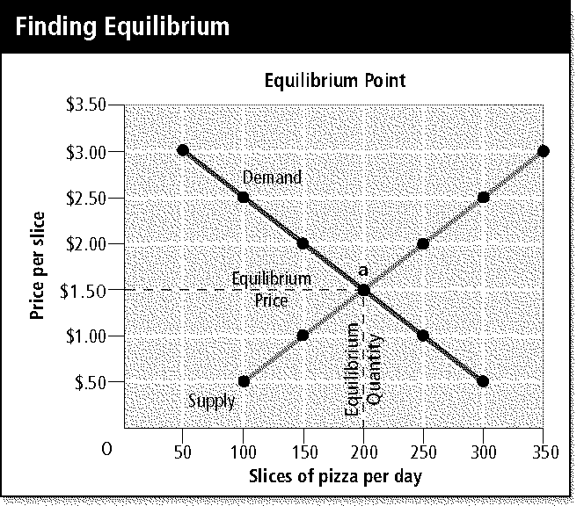

____ 31. Study the graph showing the equilibrium point for a pizzeria. Which of the following can be said about the equilibrium price and the equilibrium quantity?
a. | The quantity supplied and the quantity demanded are equal at 200 slices per day.
b. | The quantity demanded and the quantity supplied are equal at $2.00 per slice.
c. | The quantity supplied is not equal to the quantity demanded in this market, which should be at 200 per day.
d. | The maximum quantity demanded, 350 per day, is more than the quantity supplied.

____ 32. Which of the following government actions is an attempt to control the high cost of rent for lower-income families, and what has been the result of this action?
a. | Rent controls; high-income families are denied rental housing.
b. | Price ceilings; few renters with the greatest need benefit from the program.
c. | Rent ceilings; landlords can no longer discriminate.
d. | Price floors; the supply of apartments rose.

____ 33. Which word can be used twice to BEST complete this sentence? When supply ____, prices fall, and quantity demanded ____ to reach a new equilibrium.
a. | increases | c. | levels
b. | decreases | d. | reverses

____ 34. The economic impact of a holiday fad is illustrated by
a. | a negative result on the change in demand graph.
b. | a flattening of the demand curve.
c. | a sharp drop in the marginal product demand ratio.
d. | a rapid shift to the right in a market demand curve.

____ 35. Which of the following BEST explains why rationing, not a price-based system, was used during World War II?
a. | Rationing restricted production to a few products during World War II so that suppliers and manufacturers could concentrate on supporting the war effort.
b. | With rationing, consumers were able to control the distribution of food and goods while the government determined which products would be sold.
c. | Unlike a price-based system, the temporary price controls of World War II rationing helped ease shortages and guaranteed every American a minimum standard of living.
d. | Unlike price-based systems, rationing more severely restricted consumers’ buying habits, and it temporarily shifted distribution of food and goods to the military.

____ 36. Factors that make it difficult for new firms to enter a market are called
a. | start-up costs. | c. | perfect competition.
b. | barriers to entry. | d. | commodities.

____ 37. Why can an industry that enjoys economies of scale easily become a natural monopoly?
a. | because average costs drop as production rises
b. | because the market taxes less as production rises
c. | because consumers tend to appreciate monopolies
d. | because our government traditionally supports monopolies

____ 38. A firm sells natural gas to a city for one price and sells the same gas to an outlying village at another price. What is this practice called?
a. | oligopoly | c. | differentiation
b. | monopoly | d. | price discrimination

____ 39. What is an oligopoly?
a. | an agreement by a formal organization of producers to coordinate prices and production
b. | a market structure in which a few large firms dominate the market
c. | a market structure in which two firms have a price war
d. | a market structure in which a single firm dominates the market

____ 40. Which of the following is one market trend that results when a monopolistically competitive firm starts earning profits well above its costs?
a. | The firm would become an oligopolistic firm because it has effectively eliminated the competition and now dominates the market alone.
b. | The firm would try to lure 100 percent of customers by flooding the market with defective products.
c. | Fierce competition would encourage rivals to create new ways to differentiate their products and lure customers to them.
d. | The firm would eventually go out of business because demand would decrease.

____ 41. Although a sole proprietorship is the least-regulated form of business organization, which type of regulation do these business owners face that may keep them from operating out of their homes?
a. | eminent domain laws | c. | fringe benefits
b. | zoning laws | d. | a site permit

____ 42. As a sole proprietor, Jessica took out a loan to buy equipment for her in-home business. If Jessica’s business does not make enough money to pay back her loan, she will have to sell personal property to cover her outstanding obligation. Which of the following conditions affects sole proprietors but not other business organizations?
a. | unlimited personal liability | c. | proprietary liability
b. | personal obligation | d. | obligatory property

____ 43. What is the difference between a general partnership and a limited liability partnership (LLP)?
a. | In an LLP, all partners are limited from personal liability in certain situations.
b. | In a general partnership, all partners are exempt from personal liability.
c. | In an LLP, only one partner is required to be a general partner.
d. | In a general partnership, only one partner has unlimited personal liability for the firm’s actions.

____ 44. In which kind of business organization should you participate if you can afford to lose only the amount of your initial investment?
a. | dual partnership | c. | limited partnership
b. | sole proprietorship | d. | general partnership

____ 45. Who faces limited liability for the firm’s debts in a corporation?
a. | the corporation, but not its owners
b. | individual stockholders
c. | No one; only general liability can be faced.
d. | the chief executive officer

____ 46. Which of the following is an important personal financial consideration that keeps many firms from incorporating?
a. | Corporation dividends are subject to government regulation, but dividends paid to partnerships are not.
b. | Boards of directors must be paid according to the income of the firm.
c. | Stock is nontransferable, and stockholders therefore could lose considerable money if a company failed.
d. | Stockholders must pay personal income tax on dividends.

____ 47. When two giant automakers, Chrysler Corporation and Daimler-Benz, merged to form a single corporation, which type of merger was it?
a. | vertical | c. | parallel
b. | horizontal | d. | conglomerate

____ 48. Which of the following is a reason franchising has become popular in recent years?
a. | Franchise owners are free to set their own rules and operating standards, but they benefit from national ad programs.
b. | Small franchise owners enjoy a degree of control and can benefit from the support of the parent company.
c. | Because they are owned by a group of individuals for their shared benefit, franchises spread the liability.
d. | Franchising fees and royalties are generally low, and large profits can be made for minimal investment.

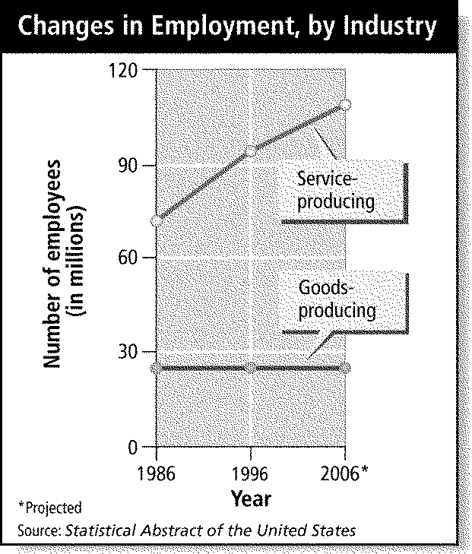

____ 49. What has happened to employment since 1986, according to the graph?
a. | Production of services is increasing at an equal rate with production of goods.
b. | Production of services is increasing faster than production of goods.
c. | Production of goods and services both continue to progress rapidly.
d. | There is a decrease in the nonlabor work force.

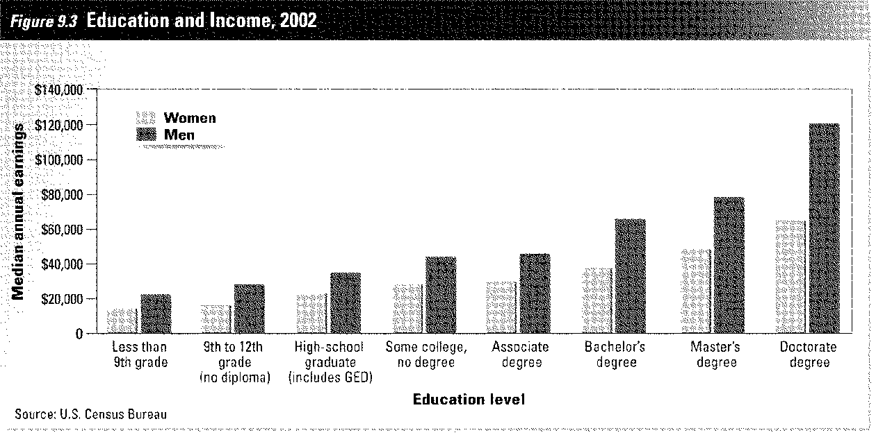

____ 50. Look at the bar graph. How does it demonstrate the learning effect?
a. | Men earn more than women, regardless of education.
b. | More women are in the labor force than men.
c. | Increases in education result in higher wages.
d. | As income increases, men and women earn the same amount.

____ 51. How can competition in a scarce labor market affect wages?
a. | Wages will go down because productivity is lower.
b. | Wages will remain level because firms want to keep supplies even and costs under control.
c. | Wages will go up to attract workers to a firm and to keep existing workers.
d. | Wages will go down to discourage new, nonskilled labor from entering the labor force.

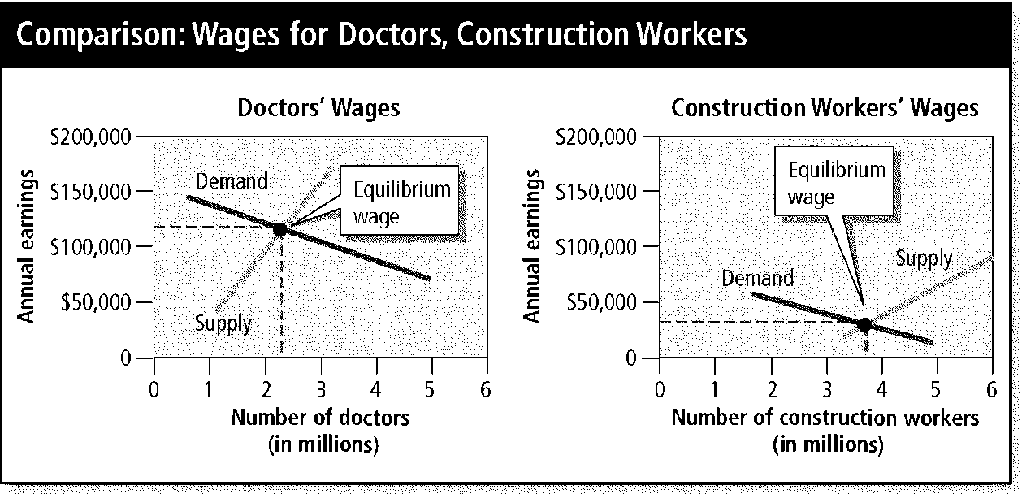

____ 52. Compare the graphs of wages for doctors and construction workers. Which of the following accounts for the difference between the equilibrium wages for these two professions?
a. | The supply of construction workers is relatively low and the demand is relatively high, but the supply of doctors is high relative to the demand for them.
b. | The equilibrium wage for construction workers is lower because doctors have a higher education level and are in the professional labor force.
c. | The equilibrium wage for doctors is lower because the working conditions for construction workers involves a higher level of danger and physical stress.
d. | The supply of doctors is relatively low and the demand is relatively high, but the supply of construction workers is high relative to the demand for them.

____ 53. Why have minorities historically tended to earn lower salaries and wages than their white counterparts, despite nondiscrimination laws?
a. | There are fewer minorities in the labor force.
b. | Minorities must compete with women, who are flooding the labor force.
c. | Whites have had access to more education and work experience.
d. | There are foreign workers taking their jobs.

____ 54. Beginning in the 1800s, labor unions have had a strong influence on the nation’s economy. What event and industry initiated the labor union movement in the United States?
a. | the Civil War and importing
b. | the Industrial Revolution and manufacturing
c. | the American Revolution and farming
d. | the Spanish-American War and exporting

____ 55. Which of the following was an effect of the Taft-Hartley Act of 1947?
a. | The act was an effort to curb union power, and mandatory union membership could be banned.
b. | The act attempted to equalize pay for men and women, allowing women the right to compete for equal pay in equal jobs.
c. | The act was an effort to strengthen union power, and mandatory union membership in some industries could be required.
d. | The act attempted to encourage more African American membership in unions, but the right-to-work laws had the opposite effect.

____ 56. To which of the following categories do collective bargaining, mediation, and arbitration belong?
a. | transactions between unions and labor organizers
b. | contractual obligations of labor management
c. | negotiations between unions and company leaders
d. | settlement techniques involving a neutral mediator

____ 57. Which of the following correctly defines money as a unit of account?
a. | It determines whether a good has value.
b. | It is determined to be legal by the person in possession of it.
c. | It provides a means for comparing the values of goods and services.
d. | It does not retain its value when saved instead of spent.

____ 58. One of the six characteristics economists use to judge how well an item serves as currency is divisibility. What does this concept mean?
a. | Currency must be divided into equal parts.
b. | Money must be indestructible and portable.
c. | Any two units of currency must be uniform.
d. | Money must be easily divided into smaller denominations.

____ 59. What is the difference between commodity money and representative money?
a. | Commodity money consists of objects used as money that contain their own value, but representative money is a specific group of the commodity objects.
b. | Commodity money consists of objects that have value in and of themselves, but representative money makes use of objects because the holder can exchange them for something else of value.
c. | Representative money allows objects to be exchanged for something else, but commodity money has value because the government decreed it is an acceptable means to pay debts.
d. | Representative money consists of objects that have value in and of themselves, but commodity money makes use of objects because the holder can exchange them for something else of value.

____ 60. Which of the following is an important power given to the federal government by the National Banking Acts of 1863 and 1864?
a. | the power to charter banks
b. | the power to create separate currencies for the North and the South
c. | the power to create a gold standard
d. | the power to test for counterfeit money

____ 61. How did the Federal Reserve System improve the banking industry in the twentieth century?
a. | It created a reserve of money that all banks would use for loans.
b. | It created a branch of government to monitor the banking system.
c. | It served as a decision-making body to regulate the federal banks.
d. | It served as a central bank with the power to lend to other banks in time of need.

Compound Interest
Start of  year | Principal  amount | Interest  earned at 5% | Principal at  end of year
– | $100.00 | $5.00 | $105.00
1 | $105.00 | $5.25 | $110.25
2 | $110.25 | $5.51 | $115.76
3 | $115.76 | $5.79 | $121.55
4 | $121.55 | $6.08 | $127.63
5 | $127.63 | $6.38 | $134.01
6 | $134.01 | $6.70 | $140.71
7 | $140.71 | $7.04 | $147.75
8 | $147.75 | $7.39 | $155.14
9 | $155.14 | $7.76 | $162.90
10 | $162.90 | $8.14 | $171.04
11 | $171.04 | $8.55 | $179.59
12 | $179.59 | $8.98 | $188.57
13 | $188.57 | $9.43 | $198.00
14 | $198.00 | $9.90 | $207.90
15 | $207.90 | $10.39 | $218.29

____ 62. According to the table, how many years does it take for the depositor to gain approximately one fourth of the original deposit in interest?
a. | 3 | c. | 5
b. | 4 | d. | 6

____ 63. What type of financial service offered at commercial banks, savings and loan associations, and credit unions is also offered at financial companies?
a. | investments | c. | installment loans
b. | checking accounts | d. | savings plans

____ 64. Which of the following happens when you use your debit card at a machine designed to read it?
a. | Your card sends a message to your bank to transfer money from your checking account directly into the store’s bank account.
b. | Your bank receives notice that funds need to be withdrawn from your checking or savings account at the end of the business day.
c. | Your bank immediately pays the funds required to the store and then invoices you for the amount on your next bank statement.
d. | Your bank confirms that money is available in your account and then adds this amount to an electronic transfer of funds that it wires to the store each week.

____ 65. How does investing contribute to a free enterprise system?
a. | Investing places large amounts of money in one corporation or business, allowing it to gain power over competition.
b. | Investing gives more money to businesses to expand and grow, creating new jobs and better products.
c. | Investing keeps investment corporations from becoming a part of the free enterprise system, which would create an imbalance.
d. | Investing distributes money evenly so that enterprises can compete equally in the marketplace.

____ 66. Which of the following is a financial intermediary?
a. | the Federal Reserve system | c. | a saver
b. | a borrower | d. | a bank

____ 67. Why should you consider liquidity, not just return, when making savings and investment decisions?
a. | You should consider the rate of return in relation to the GNP.
b. | You should consider how fast the market is changing at any given moment.
c. | You should consider whether you will need ready access to your funds.
d. | You should consider a company’s portfolio as a whole and not just look at a single investment.

____ 68. Which type of bond carries the LEAST amount of risk?
a. | treasury bonds, because they are backed by the U.S. government
b. | corporate bonds, because they are exempt from federal taxes
c. | municipal bonds, because they are backed by state and local taxes
d. | international bonds, because they are backed by foreign currencies

____ 69. Which of the following are benefits of money market mutual funds?
a. | They cost little, and the investor chooses the term of maturity.
b. | Intermediaries buy short-term financial assets, and investors receive higher interest.
c. | Investors have easy access to their money, and they are covered by FDIC insurance.
d. | The funds are covered by FDIC insurance, and they are available for various fixed amounts of time.

____ 70. Liquidity is important to John. If he wants to make certain that he can resell his financial assets, in which market classification must he participate?
a. | primary market | c. | capital market
b. | secondary market | d. | money market

____ 71. How do investors usually act during a bear market?
a. | Investors buy stock in expectation of higher profits because the stock market falls for a period of time.
b. | Investors sell stock in expectation of lower profits because the stock market rises for a period of time.
c. | Investors buy stock in expectation of higher profits because the stock market rises for a period of time.
d. | Investors sell stock in expectation of lower profits because the stock market falls for a period of time.

____ 72. Why might someone consider the Standard & Poor’s 500 (S & P 500) a better measurement of stock performance than the Dow Jones Industrial Average?
a. | The S & P 500 reports stock performance daily, and the Dow reports weekly.
b. | The Dow reports on 30 stocks and the S & P 500 tracks 500 stocks as a measure of overall stock performance.
c. | The S & P 500 predicted the Great Crash of 1929, and the Dow predicted a rising bull market.
d. | The Dow specializes in the stocks of a single industry, and the S & P 500 reports on the stocks of a variety of industries.

____ 73. What is the money an investor receives above and beyond the money initially invested called?
a. | savings | c. | return
b. | liquidity | d. | investment

____ 74. The Securities and Exchange Commission is
a. | an independent agency that advises the government about financial markets.
b. | a government agency that sells treasury bonds and other United States financial obligations.
c. | a government agency that regulates financial markets and investment companies.
d. | a privately owned investment corporation that sells bonds and other investments.

____ 75. What is the gold standard?
a. | A system that uses actual gold coins as a country’s money.
b. | A system in which a country’s money is backed with gold.
c. | A currency system in which each dollar is worth 1/20 of a pound of gold.
d. | A money system in which the paper currency is good in more than one country.

____ 76. Why would an economist use real GDP rather than nominal GDP to measure growth?
a. | Real GDP calculates the GDP for a longer period of time.
b. | Real GDP uses current prices to measure the year’s output.
c. | Nominal GDP applies to only a small number of industries.
d. | Real GDP reflects output more accurately than nominal GDP by using constant prices.

____ 77. Which of the following economic activities does NOT illustrate the limitations of calculating GDP?
a. | nonmarket activities | c. | the underground economy
b. | negative externalities | d. | depreciation

____ 78. In a real economy, which two factors can change the level of nominal GDP?
a. | constant prices and quality of life
b. | individual markets and economic planning
c. | inflation and deflation
d. | intermediate goods and national income accounting

____ 79. Four factors, both expected and unexpected, perpetuate the business cycle. Which of the following is NOT one of these factors?
a. | business investments | c. | stagflation
b. | interest rates and credit | d. | external shocks

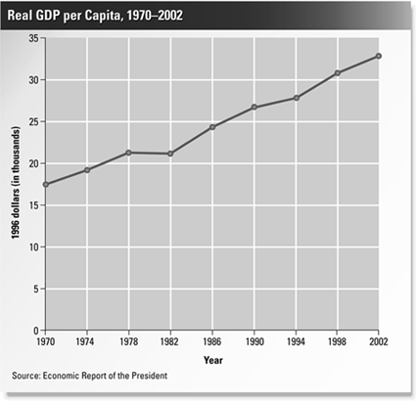

____ 80. What happened following the stock market crash in 1929 to account for the change in real GDP in the 1930s shown in this graph?
a. | During the Great Depression, overproduction of goods by factories led to layoffs and unemployment.
b. | During the Great Depression, factories were idle, and thousands of Americans lost their jobs and homes.
c. | A tax rebate miscalculated the elasticity of the market, and thousands lost money in stocks, lost their homes, and became unemployed.
d. | The rapid economic downturn did not recover until World War II, when the government boosted defense spending.

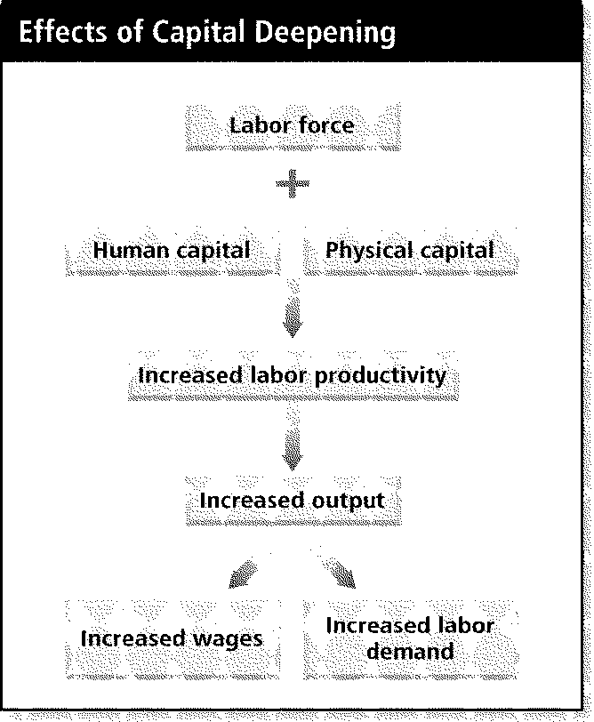

____ 81. According to the diagram, what is one beneficial effect of capital deepening?
a. | increased wages | c. | decreased labor productivity
b. | decreased wages | d. | decreased labor demand

____ 82. Chris decided that this year she would put 25 percent of her income in savings and investments, an increase of 5 percent over the previous year. If a majority of people did this, how would the economy be affected?
a. | The economy would suffer because less money would be spent on goods and services.
b. | The economy would prosper because more investment funds would be available for businesses.
c. | There would be no effect because the same amount of money would enter the economy.
d. | The economy would suffer because the government would collect fewer income taxes.

____ 83. What source of economic growth is reflected in the economy by an increase in productivity without an increase in land, labor, or capital?
a. | technological progress | c. | population growth
b. | foreign trade | d. | savings and investment

____ 84. Which one of these people lost his or her job because of structural unemployment?
• | Jordan graduated from law school and is interviewing with various law firms.
• | Thomas’s job as a landscaper is on hold until the spring.
• | Sonya dropped out of school and now fails to meet the minimum requirements for her job.
• | Eva lost her job at a major interior design firm during the recession in the 1980s.

a. | Jordan | c. | Sonya
b. | Thomas | d. | Eva

____ 85. According to the principle of cyclical unemployment, what will occur when the demand for goods and services drops during a recession?
a. | The business cycle resumes an upward trend.
b. | The demand for labor drops.
c. | The demand for labor rises.
d. | No frictional unemployment exists.

____ 86. Ten years ago, a house sold for $54,000. Today the same house is valued at $108,000. What has inflation done to consumers’ purchasing power?
a. | reduced it | c. | doubled it
b. | increased it | d. | stopped it

____ 87. During a war, the government puts pressure on producers for heavy equipment, supplies, and services, making each more valuable. What theory about inflation does this condition represent?
a. | cost-pull | c. | quantity
b. | cost-push | d. | demand-pull

____ 88. If you lived on a fixed income, how would you be affected by inflation?
a. | You would be financially stressed because your income does not increase when prices go up.
b. | You would be hit hard because rising inflation would lower your rate of pay.
c. | You would benefit because you would have more purchasing power.
d. | There would be little effect because income is not tied to inflation.

____ 89. During the 1990s, the inflation and unemployment trends in the United States changed. What was unusual in the 1990s?
a. | Unemployment reached high levels, but inflation fell to less than five percent.
b. | Although inflation remained at less than three percent, unemployment fell to very low levels.
c. | Unemployment and inflation maintained the same ratio during the 1990s.
d. | Both unemployment and inflation rose to high levels.

____ 90. The poverty threshold, or poverty line, varies according to what?
a. | the census | c. | the size of the family
b. | nationwide income averages | d. | the inflation rate

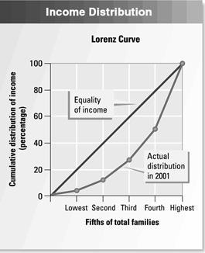

____ 91. What does the Lorenz Curve show about the distribution of income in 2001?
a. | The lowest 40 percent received 20 percent of total income.
b. | Two-fifths of households received 10.5 percent of income.
c. | The distribution of income was roughly equal.
d. | The distribution of income was not equal.

____ 92. What is the Consumer Price Index?
a. | a measure of prices of housing and rental costs all over the country
b. | an index of prices of items used by manufacturers and retailers
c. | an index determined by measuring the price of standard goods bought by urban consumers
d. | an index of the cost of living for all U.S. consumers

Final Review
Answer Section

MULTIPLE CHOICE

1. ANS: D DIF: Medium REF: 4 OBJ: 1.1.1
STO: TEKS: 5A, TEKS: 24A TOP: scarcity and shortage

2. ANS: C DIF: Medium REF: 4-5 OBJ: 1.1.2
STO: TEKS: 12A, TEKS: 23A TOP: physical capital

3. ANS: A DIF: Easy REF: 8 OBJ: 1.2.1
STO: TEKS: 5B, TEKS: 23A TOP: trade-offs/guns and butter

4. ANS: B DIF: Medium REF: 9 OBJ: 1.2.2
STO: TEKS: 5B, TEKS: 25B TOP: opportunity cost

5. ANS: B DIF: Medium REF: 10-11 OBJ: 1.2.3
STO: TEKS: 5B, TEKS: 25B TOP: thinking at the margin

6. ANS: C DIF: Hard REF: 15 OBJ: 1.3.1
STO: TEKS: 5B, TEKS: 23B TOP: production possibilities curve

7. ANS: A DIF: Medium REF: 25 OBJ: 2.1.2
STO: TEKS: 21A, TEKS: 23A TOP: economic goals and societal values

8. ANS: B DIF: Easy REF: 26-27 OBJ: 2.1.3
STO: TEKS: 21B, TEKS: 23A TOP: traditional economies

9. ANS: B DIF: Hard REF: 29-30 OBJ: 2.2.2
STO: TEKS: 6A, TEKS: 23A TOP: factor market exchange/free market economy

10. ANS: C DIF: Medium REF: 31-32 OBJ: 2.2.3
STO: TEKS: 4A, TEKS: 23A TOP: competition/regulating force of free market

11. ANS: A DIF: Medium REF: 38 OBJ: 2.3.3
STO: TEKS: 10A, TEKS: 23A TOP: problems of centrally planned economies

12. ANS: B DIF: Medium REF: 40-41 OBJ: 2.4.1
STO: TEKS: 15A, TEKS: 23A TOP: rise of mixed economy

13. ANS: D DIF: Hard REF: 43 OBJ: 2.4.3
STO: TEKS: 21B, TEKS: 23A TOP: continuum of mixed economies

14. ANS: D DIF: Medium REF: 44 OBJ: 2.4.1
STO: TEKS: 4B, TEKS: 23A TOP: free enterprise

15. ANS: B DIF: Easy REF: 53 OBJ: 3.1.2
STO: TEKS: 4A, TEKS: 23A TOP: principles of free enterprise

16. ANS: B DIF: Hard REF: 54 OBJ: 3.1.3
STO: TEKS: 15B, TEKS: 23A TOP: public disclosure laws

17. ANS: C DIF: Medium REF: 58 OBJ: 3.2.3
STO: TEKS: 16A, TEKS: 23A TOP: stability

18. ANS: C DIF: Easy REF: 59 OBJ: 3.2.4
STO: TEKS: 26A, TEKS: 23A TOP: technology and productivity

19. ANS: C DIF: Medium REF: 63 OBJ: 3.3.1
STO: TEKS: 15A, TEKS: 23A TOP: public goods

20. ANS: D DIF: Medium REF: 59-60 OBJ: 3.2.3
STO: TEKS: 26A, TEKS: 23A TOP: technology's effect

21. ANS: C DIF: Easy REF: 79 OBJ: 4.1.1
STO: TEKS: 7A, TEKS: 23A TOP: law of demand

22. ANS: A DIF: Medium REF: 80 OBJ: 4.1.2
STO: TEKS: 7A, TEKS: 23A TOP: income effect

23. ANS: C DIF: Medium REF: 81-83, 85 OBJ: 4.1.3
STO: TEKS: 7B, TEKS: 23B TOP: market demand

24. ANS: A DIF: Medium REF: 87 OBJ: 4.2.2
STO: TEKS: 7A, TEKS: 23A TOP: inferior goods/demand shift

25. ANS: D DIF: Medium REF: 91-94 OBJ: 4.3.2
STO: TEKS: 7A, TEKS: 23A TOP: elasticity

26. ANS: B DIF: Easy REF: 101 OBJ: 5.1.1
STO: TEKS: 7A, TEKS: 24A TOP: law of supply

27. ANS: A DIF: Hard REF: 103-104 OBJ: 5.1.2
STO: TEKS: 7B, TEKS: 25B TOP: market supply schedule

28. ANS: D DIF: Hard REF: 109 OBJ: 5.2.1
STO: TEKS: 2B, TEKS: 23F TOP: marginal product of labor/diminishing marginal returns

29. ANS: B DIF: Hard REF: 110 OBJ: 5.2.1
STO: TEKS: 2B, TEKS: 23F TOP: marginal product of labor/negative marginal return

30. ANS: C DIF: Medium REF: 117-119 OBJ: 5.3.2
STO: TEKS: 15B, TEKS: 23A TOP: government’s influence on supply

31. ANS: A DIF: Hard REF: 126 OBJ: 6.1.1
STO: TEKS: 7B, TEKS: 23B TOP: equilibrium

32. ANS: B DIF: Medium REF: 129-130 OBJ: 6.1.4
STO: TEKS: 3B, TEKS: 23A TOP: price ceiling

33. ANS: A DIF: Medium REF: 135 OBJ: 6.2.2
STO: TEKS: 7A, TEKS: 23A TOP: changing equilibrium

34. ANS: D DIF: Medium REF: 136 OBJ: 6.2.3
STO: TEKS: 7B, TEKS: 23B TOP: shifts in demand

35. ANS: C DIF: Hard REF: 142 OBJ: 6.3.3
STO: TEKS: 15A, TEKS: 23A TOP: rationing versus price-based

36. ANS: B DIF: Easy REF: 153 OBJ: 7.1.3
STO: TEKS: 9C, TEKS: 24A TOP: barriers to entry

37. ANS: A DIF: Medium REF: 158 OBJ: 7.2.2
STO: TEKS: 9C, TEKS: 23A TOP: natural monopolies

38. ANS: D DIF: Medium REF: 163 OBJ: 7.2.3
STO: TEKS: 9C, TEKS: 23A TOP: price discrimination

39. ANS: B DIF: Easy REF: 169 OBJ: 7.3.1
STO: TEKS: 9C, TEKS: 24A TOP: oligopoly

40. ANS: C DIF: Hard REF: 169 OBJ: 7.3.3
STO: TEKS: 9C, TEKS: 23A TOP: profits in monopolistically competitive firms

41. ANS: B DIF: Easy REF: 187 OBJ: 8.1.1
STO: TEKS: 3B, TEKS: 23A TOP: zoning laws

42. ANS: A DIF: Medium REF: 187 OBJ: 8.1.3
STO: TEKS: 9B, TEKS: 23A TOP: liability

43. ANS: A DIF: Medium REF: 190-191 OBJ: 8.2.1
STO: TEKS: 9A, TEKS: 24A TOP: general versus llp

44. ANS: C DIF: Easy REF: 190 OBJ: 8.2.3
STO: TEKS: 9A, TEKS: 23A TOP: disadvantage of partnerships

45. ANS: B DIF: Easy REF: 195 OBJ: 8.3.1
STO: TEKS: 9B, TEKS: 23A TOP: stockholder liability

46. ANS: D DIF: Medium REF: 198 OBJ: 8.3.3
STO: TEKS: 11C, TEKS: 23A TOP: double taxation

47. ANS: B DIF: Easy REF: 199 OBJ: 8.3.4
STO: TEKS: 2A, TEKS: 23A TOP: horizontal merger

48. ANS: B DIF: Medium REF: 202 OBJ: 8.4.1
STO: TEKS: 2A, TEKS: 23A TOP: franchises

49. ANS: B DIF: Medium REF: 213 OBJ: 9.1.2
STO: TEKS: 16B, TEKS: 23F TOP: graph reading

50. ANS: C DIF: Easy REF: 214 OBJ: 9.1.4
STO: TEKS: 7A, TEKS: 23F TOP: graph reading

51. ANS: C DIF: Medium REF: 219-220 OBJ: 9.2.1
STO: TEKS: 2B, TEKS: 25B TOP: supply and demand in the labor market

52. ANS: D DIF: Hard REF: 222 OBJ: 9.2.2
STO: TEKS: 7B, TEKS: 23F TOP: supply and demand affects wages

53. ANS: C DIF: Easy REF: 224 OBJ: 9.2.3
STO: TEKS: 7A, TEKS: 23A TOP: wage discrimination

54. ANS: B DIF: Easy REF: 229 OBJ: 9.3.2
STO: TEKS: 19B, TEKS: 23A TOP: roots of labor union movement

55. ANS: A DIF: Medium REF: 231 OBJ: 9.3.3
STO: TEKS: 19B, TEKS: 23A TOP: decline in union power/membership

56. ANS: C DIF: Medium REF: 233-234 OBJ: 9.3.4
STO: TEKS: 2A, TEKS: 23A TOP: labor and management negotiations

57. ANS: C DIF: Medium REF: 244 OBJ: 10.1.1
STO: TEKS: 11A, TEKS: 23A TOP: money as a unit of account

58. ANS: D DIF: Easy REF: 245-246 OBJ: 10.1.2
STO: TEKS: 11A, TEKS: 24A TOP: characteristics of money

59. ANS: B DIF: Hard REF: 246-248 OBJ: 10.1.3
STO: TEKS: 11A, TEKS: 24A TOP: sources of money’s value

60. ANS: A DIF: Easy REF: 252-253 OBJ: 10.2.2
STO: TEKS: 15A, TEKS: 23A TOP: national banking acts

61. ANS: D DIF: Medium REF: 254-255 OBJ: 10.2.3
STO: TEKS: 18B, TEKS: 23A TOP: the federal reserve system

62. ANS: B DIF: Easy REF: 261 OBJ: 10.3.2
STO: TEKS: 11B, TEKS: 23F TOP: compound interest

63. ANS: C DIF: Medium REF: 262-263 OBJ: 10.3.3
STO: TEKS: 8A, TEKS: 23A TOP: financial institutions/finance companies

64. ANS: A DIF: Medium REF: 263-264 OBJ: 10.3.4
STO: TEKS: 11A, TEKS: 23A TOP: electronic banking/debit cards

65. ANS: B DIF: Easy REF: 271 OBJ: 11.1.1
STO: TEKS: 11C, TEKS: 23A TOP: investing and free enterprise

66. ANS: D DIF: Medium REF: 272-273 OBJ: 11.1.3
STO: TEKS: 11B, TEKS: 23A TOP: financial intermediaries

67. ANS: C DIF: Medium REF: 274-275 OBJ: 11.1.4
STO: TEKS: 11B, TEKS: 25B TOP: liquidity

68. ANS: A DIF: Medium REF: 280-282 OBJ: 11.2.2
STO: TEKS: 11C, TEKS: 23A TOP: bonds

69. ANS: B DIF: Medium REF: 282 OBJ: 11.2.3
STO: TEKS: 11B, TEKS: 23A TOP: money market mutual funds

70. ANS: B DIF: Medium REF: 283 OBJ: 11.2.4
STO: TEKS: 11C, TEKS: 23A TOP: primary versus secondary markets

71. ANS: D DIF: Medium REF: 290 OBJ: 11.3.3
STO: TEKS: 11C, TEKS: 23A TOP: bear markets

72. ANS: B DIF: Medium REF: 290 OBJ: 11.3.3
STO: TEKS: 11C, TEKS: 23A TOP: measuring stock performance

73. ANS: C DIF: Easy REF: 274-275 OBJ: 11.1.4
STO: TEKS: 11B, TEKS: 24A TOP: investing

74. ANS: C DIF: Medium REF: 281 OBJ: 11.2.3
STO: TEKS: 15A, TEKS: 24A TOP: securities and exchange commission

75. ANS: B DIF: Medium REF: 253 OBJ: 10.2.2
STO: TEKS: 11A, TEKS: 24A TOP: gold standard

76. ANS: D DIF: Easy REF: 303-304 OBJ: 12.1.3
STO: TEKS: 16B, TEKS: 23A TOP: nominal and real gdp

77. ANS: D DIF: Medium REF: 304-305 OBJ: 12.1.4
STO: TEKS: 16B, TEKS: 23A TOP: limitations of gdp

78. ANS: C DIF: Medium REF: 306-308 OBJ: 12.1.5
STO: TEKS: 16B, TEKS: 23A TOP: nominal gdp

79. ANS: C DIF: Easy REF: 311-314 OBJ: 12.2.2
STO: TEKS: 19C, TEKS: 23A TOP: factors in the business cycle

80. ANS: B DIF: Easy REF: 314-315 OBJ: 12.2.4
STO: TEKS: 19C, TEKS: 23F TOP: business cycles

81. ANS: A DIF: Easy REF: 320 OBJ: 12.3.2
STO: TEKS: 2B, TEKS: 23F TOP: capital deepening

82. ANS: B DIF: Medium REF: 320-321 OBJ: 12.3.3
STO: TEKS: 1B, TEKS: 23A TOP: savings and capital deepening

83. ANS: A DIF: Hard REF: 322-324 OBJ: 12.3.5
STO: TEKS: 26A, TEKS: 24A TOP: technological progress

84. ANS: C DIF: Medium REF: 331-334 OBJ: 13.1.1
STO: TEKS: 16B, TEKS: 23A TOP: types of unemployment

85. ANS: B DIF: Medium REF: 333-334 OBJ: 13.1.1
STO: TEKS: 7A, TEKS: 23A TOP: cyclical unemployment

86. ANS: A DIF: Easy REF: 338-339 OBJ: 13.2.1
STO: TEKS: 7A, TEKS: 23A TOP: purchasing power

87. ANS: D DIF: Medium REF: 341 OBJ: 13.2.3
STO: TEKS: 7A, TEKS: 24A TOP: causes of inflation

88. ANS: A DIF: Medium REF: 342-343 OBJ: 13.2.3
STO: TEKS: 16B, TEKS: 23A TOP: inflation and income

89. ANS: B DIF: Hard REF: 343 OBJ: 13.2.4
STO: TEKS: 16B, TEKS: 23A TOP: trends in inflation in 1990s

90. ANS: C DIF: Easy REF: 345-346 OBJ: 13.3.1
STO: TEKS: 16A, TEKS: 24A TOP: the poverty threshold

91. ANS: D DIF: Medium REF: 348-349 OBJ: 13.3.3
STO: TEKS: 4A, TEKS: 23F TOP: lorenz curve/distribution of income

92. ANS: D DIF: Medium REF: 339-340 OBJ: 13.2.2
STO: TEKS: 16B, TEKS: 24A TOP: consumer price index

